37. Using OpenCV to Play Video in Reverse Mode
Aim
To read and play a video in reverse mode using OpenCV.
Algorithm
- Import the OpenCV library.
- Open the video file using cv2.VideoCapture().
- Find the total number of frames in the video.
- Start reading frames from the last frame.
- Display each frame in reverse order.
- Press q to stop the video.
- Release the video and close all windows.
Python Program
import cv2

# Open the video
cap = cv2.VideoCapture("video.mp4")

# Get total number of frames
total_frames = int(cap.get(cv2.CAP_PROP_FRAME_COUNT))

# Start from the last frame
for frame_no in range(total_frames - 1, -1, -1):

cap.set(cv2.CAP_PROP_POS_FRAMES, frame_no)

ret, frame = cap.read()

if not ret:
continue

cv2.imshow("Reverse Video", frame)

# Press q to exit
if cv2.waitKey(30) & 0xFF == ord('q'):
break

# Release resources
cap.release()
cv2.destroyAllWindows()
Output 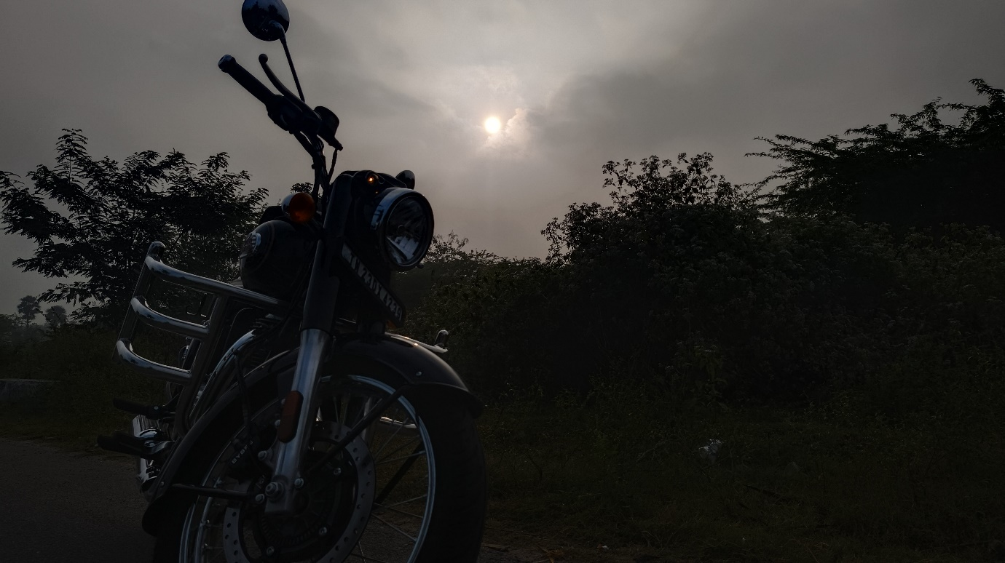
Result
Thus, the given video was successfully played in reverse mode using OpenCV.

